OpenERP THUNDERBIRD PLUG-IN INSTALLATION GUIDE

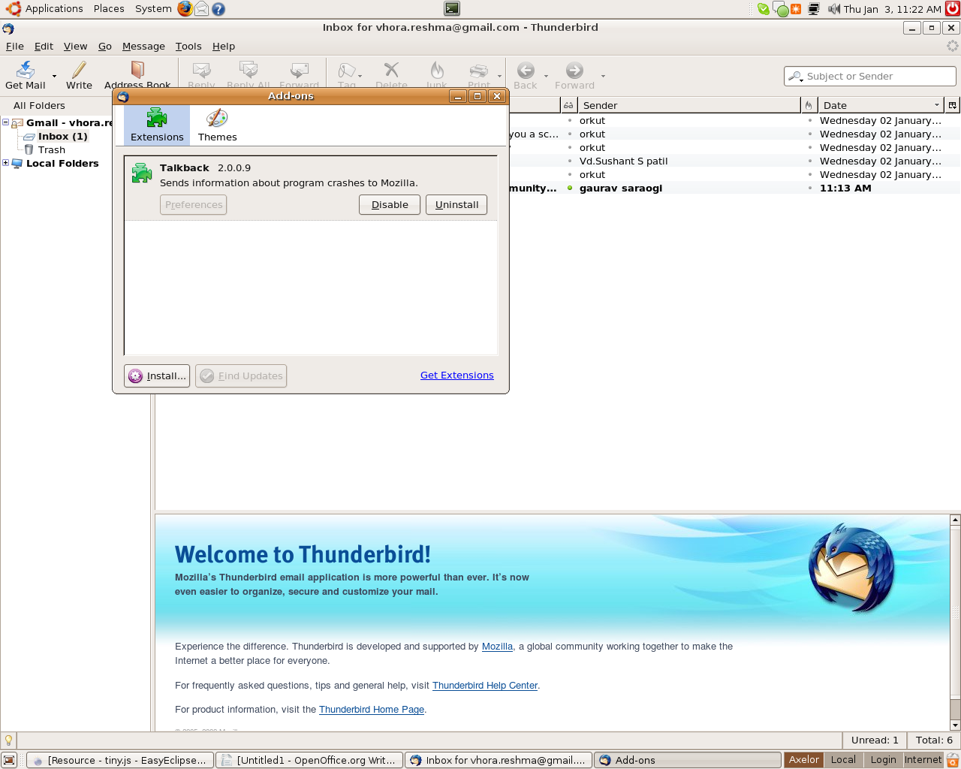
INRTODUCTION:
The thunderbird plug-in supports the file with extension (.xpi). The thunderbird plug-in will also be a (.xpi) file.

How to install thunderbird plug-in ?
- From Menu Bar, Open Tools -> Add ons.
- Now click on install button and a browser window will appear.
- Just select the (.xpi) file and click ok, a new software installation window will appear and within a short time “Install Now” button will be enabled.
- Click on “Install Now” and restart Thunderbird.
- Now Thunderbird plug-in is installed.

How to set the tiny plug-in icon “Archive to Tiny” on the tab panel ?

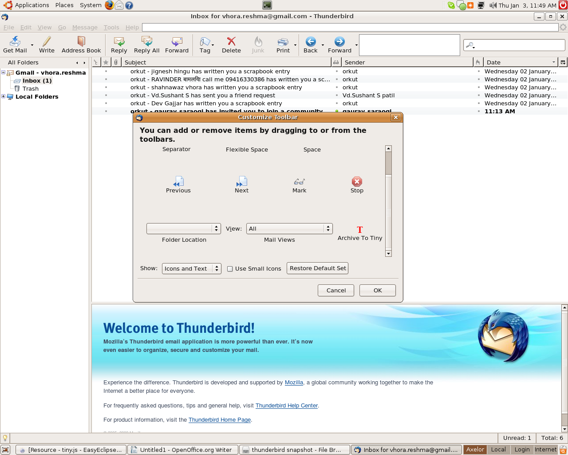
- Right click on the tab panel and click on “Customize” and a customize toolbar window will appear.
- Now Drag-n-Drop the “Archive To Tiny” icon on the toolbar and clik ok.
- Now the Thunderbird plug-in is fully installed.

Enjoy Archiving your Thunderbird E-mails to OpenERP.

